**Leader Overview**

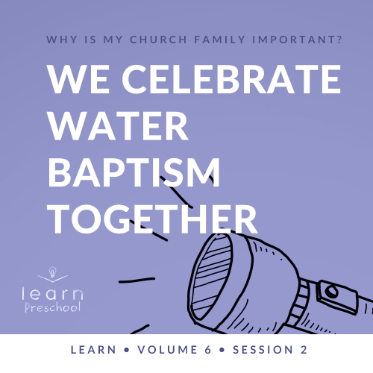

**Volume Overview**

**Why is my church family important?**

*When we think of church, it’s easy for our mind to be instantly drawn to the building where we attend. However, in God’s design, the church isn’t the building that we gather in. Instead, church has everything to do with the people who are gathered there. In essence, the biblical church is not a building that we go to but a family of believers that we belong to*.

*As our Father, God’s heart is to adopt us into His family (*[*Ephesians 1:5*](https://ref.ly/logosref/Bible.Eph1.5)*). When we choose to put our faith in Jesus, we instantly join God’s family. We not only belong to Him but we also belong to each other. Just like our natural families here on earth were meant to function, God uses our church family to meet our needs. A healthy church family offers love, encouragement, guidance, and accountability. As the family of God—the Church—we grow together, celebrate together, share together, and even serve together. As we make a commitment to God’s family, we will become stronger, more devoted followers of Jesus*.

**Session Overview**

**We Celebrate Water Baptism Together**

*In this* **Learn** *session, preschoolers will discover the importance of water baptism. In the New Testament, we read about Jesus being baptized by John the Baptist. Jesus also gave His disciples the charge to share the gospel and baptize people in the name of the Father, the Son, and the Holy Spirit. In today’s Bible story, kids will learn about a woman who was baptized in water. At a young age, kids will learn baptism is a public celebration of their commitment to Christ*.

**Bible Lesson**

Lydia and Her Family Are Baptized in Water

[Acts 16:11–15](https://ref.ly/logosref/Bible.Ac16.11-15)

**Faith Fact**

We celebrate together.

**Faith Verse**

[Matthew 18:20](https://ref.ly/logosref/Bible.Mt18.20) (NLT)

“For where two or three gather together as my followers, I am there among them.”

**Preparing for the Session**

**Leader Preparation Time: 20–25 Minutes**

|  |
| --- |
| ***You Will Need***  ***Preservice Activities***  *• Toys*  *• Birthday hat*  *• Birthday cupcakes*  *Large Group*  *• Bible*  *• Worship songs (Song suggestions: Jesus loves me (hip hop remix) by Listener Kids; “The Lord Is My Rock” by Freedom Kids; “Nothing Is Impossible” by PlanetShakers Kids)*  *• For groups not using a phone or tablet only, add:*  *• Projector or TV*  *• Laptop*  *•* ***Countdown60 Video****–60 seconds*  *•* ***Faith Fact Sound*** *video (bell ringing)*  *•* ***Faith Fact Slide***  *•* ***Faith Verse Slide***  *•* ***Bible Lesson Video A***  *•* ***Bible Lesson Video B***  ***Small Group***  *• Party hat, one per group*  *• Music*  *• Device to play music on*  *•* ***Small Group Activity Page****, one per kid*  *• Crayons, markers, or colored pencils*  *• Small balloons, one per kid*  *• Plastic cups, one per kid*  *•* ***Countdown60 Video****–60 seconds*  *• Small foam or plastic cup, one per group*  *• Large plate, one per group*  *• Baking soda*  *• Vinegar*  *• Tablecloth*  *To access session content and videos from a computer, visit:* [*BibleEngagementProject.com/downloads*](https://bibleengagementproject.com/downloads) |
| ***Getting Ready***  ***Preservice Activities***  *• Set out toys and snacks.*  ***Large Group***  *• Download videos and slides if needed.*  *• Select worship song(s) and have them ready to play.*  ***Small Group***  *• Find fun music to play.*  *• Print copies of the* ***Small Group Activity Page****, one per kid.*  *• Blow up the balloons to a size that will rest on top of the cups.*  *• Cover the table with a tablecloth.*  *First time leading* Learn *for Preschool? Check out the* [Facilitator Guide](https://0b769b0ed3569ef9d18b-f88d8272f61086866d50d048b43ef630.ssl.cf2.rackcdn.com/sites/biblengagementproject/Listen_Facilitator_Guide.pdf). |

**Preservice Activities**

*See what’s needed at the beginning of the session.*

**Bible Story Warm-Up**

*As kids enter, have them sit in a circle*.

How many of you like parties? *(Group response)* I like parties, too. They usually mean we’re celebrating something or someone special. In fact, I have this hat with me. *(Hold up hat.)* Does anyone know what kind of hat this? *(Allow responses.)* Yes! It’s a birthday party hat.

Have you ever worn a hat like this?

Who or what were you celebrating when you wore it?

What’s your favorite thing about a birthday party?

What are some things you might see at a party?

Fantastic! Those are all great answers. The great thing about this party hat is that it tells people it’s time to celebrate. Today, we’ll learn about a special celebration that tells other people that you belong to God’s family.

**Snack**

**Party Cupcakes**

*As kids are eating the snack, share the following:*

Today, as we eat our snack, I want you to think about your favorite birthday gift. It can be something big or something small. Who gave you that gift? *(Allow responses.)* Those people showed that they loved you by giving you a gift. They spent time picking out the perfect gift just for you. Have you ever given a gift to someone? *(Allow responses.)*

* *Be prepared to share your own story about giving a gift if the kids are unable to think of a story to tell you*.

Why did you want to give them a gift? *(Allow responses.)* Those are great reasons. I imagine the person loved the gift you gave them. They probably showed other people their awesome gift.

Did you know that God has given each one of us a gift? *(Group response)* He gave us the gift of being in His family through His Son Jesus. There’s a great way we can show others that gift and celebrate what God has done in our life. I can’t wait to learn more about this with you during our Bible story today.

**Free Play**

*Any extra time can be spent playing with toys*.

**Transition**

*A few minutes before service begins have kids make their way to the large group area and sit in their designated areas*.

**Large Group**

**25 Minutes**

*See what’s needed at the beginning of the session.*

**Introduction**

Hey, friends! I’m so pumped that we’re going to have fun learning from God’s Word together. *(Hold up Bible.)* If you’re excited to learn with me, say, “Let’s celebrate!” *(Group response)*

Today, we’ll talk about celebrating with people at church. Does anyone know what *celebrate* means? *(Allow responses.)* Celebrate means that we remember something in a special way. When it’s your birthday, we remember the day you were born. If it’s a going away party for someone who’s moving, it means we remember fun times we had together before we say goodbye.

There are a lot of great things we can remember and celebrate. Did you know we can also remember the day we gave our heart to Jesus? *(Group response)* That’s like our spiritual birthday. It’s the day that Jesus made us new. One way people can celebrate that is when they get baptized in water. Have you ever watched someone get baptized in water? Raise your hand. *(Group response)* That’s what we will talk about today.

**Faith Fact**

When someone gets baptized in water, it should be an awesome celebration. We celebrate each other, and God celebrates with us, too. That reminds me of our Faith Fact: **We celebrate together**.

• *Show the* ***Faith Fact Slide***.

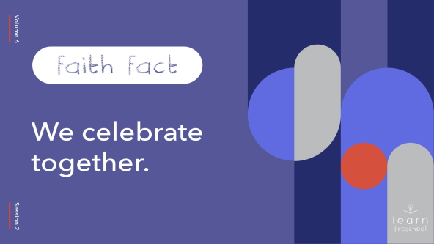

Let’s say it together. Pretend you have confetti in your hands as we say it. Confetti is tiny, colorful pieces of paper. Pretend to throw it in the air as we say the Faith Fact*.* Ready? **We celebrate together.** *(Group response)* Now, let’s pretend we’re blowing out birthday candles when we finish saying our Faith Fact. Ready? **We celebrate together.** Good job!

**Bible Time**

The Bible talks a lot about the importance of being together. When we’re together with other people, it’s easier to celebrate what God is doing in our lives. I hope Lizzy tells us more about being baptized in water. Let’s check in with her and see.

• *Play* ***Bible Lesson Video A***.

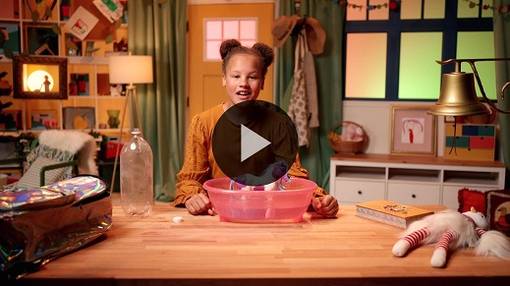

That was so good. I like that Lizzy used her toys to show us what happens when someone is baptized in water. I liked hearing you practice your Faith Verse because that means you’re learning God’s Word.

**Worship**

Another way we celebrate together is when we worship. It’s our chance to celebrate who God is. When we focus on God and think about Him, it’s easy to celebrate Him.

**Praise**

Are you happy that God loves you? Wave your hands in the air. *(Group response)*

Are you glad you can celebrate together with friends? Clap your hands three times. *(Group response)*

Who wants to tell God how awesome He is? Shout, “Oh yeah!” *(Group response)*

**Sing**

We can celebrate how great God is through singing. When we sing worship songs together, we get to tell God how much we love Him. Celebrating God is one of my favorite things to do, and I love to do it together with you.

• *Lead the kids in singing one or two songs. See song suggestions at the beginning of the session*.

**Prayer**

That was fantastic! You all did such a good job of focusing on God as we sang together. Let’s pause and take a minute to talk to God.

|  |
| --- |
| Dear God, thank You for the amazing gift You gave us in Jesus. We want to celebrate new life in Him. Help us to tell others how much we love You. Amen. |

**Bible Time cont’d**

Do you know what’s one of the best things we can do together? *(Hold up Bible) (Group response)* That’s right! Learn from the Bible together. Let’s see what Lizzy is up to!

• *Play* ***Bible Lesson Video B***.

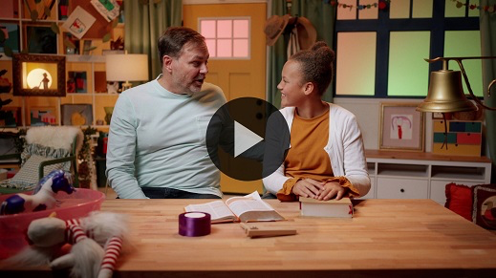

Did you enjoy today’s Bible story? *(Group response)* I did. It’s always fun learning with you and Lizzy. In our Bible story today, who was baptized in water? *(Allow responses.)* That’s right! When Lydia learned about all God had done for her, her heart was so full she wanted to follow Jesus. That same day Lydia and her family were baptized in water. They wanted everyone to know that they were now a part of God’s family.

Paul was probably very excited for them. I think it could have been quite the celebration. Being baptized in water as a family was such a special moment. What was your favorite part of the story? *(Allow responses.)*

**Response Time**

• *Play a worship song quietly*.

When I think about who Jesus is and all that He’s done for me, I want to smile. *(Show a big smile.)* It’s like having my own celebration by myself. Let’s try that. Let’s think of things Jesus has done for us. When you think of something, smile big and tell us what it is.

• *Pause while kids remember and share things with the group*.

Those are great things to celebrate. Now, let’s pray together and thank Jesus for all the things we can celebrate together.

• *Optional: Have the kids repeat phrases of the prayer after you*.

|  |
| --- |
| Dear Jesus, thank You for everything You’ve done for me. I want to celebrate what You’ve done in my life. Help me to see what You are doing in my friends’ lives, so I can celebrate with them. Amen. |

**Faith Verse**

Our Faith Verse is about being together. Did you know God loves it when we learn Bible verses from His Word? Let’s say our Faith Verse and do the actions together.

[Matthew 18:20](https://ref.ly/logosref/Bible.Mt18.20) (NLT)

“For where two or three gather together as my followers, I am there among them.”

• *Show the* ***Faith Verse Slide***.

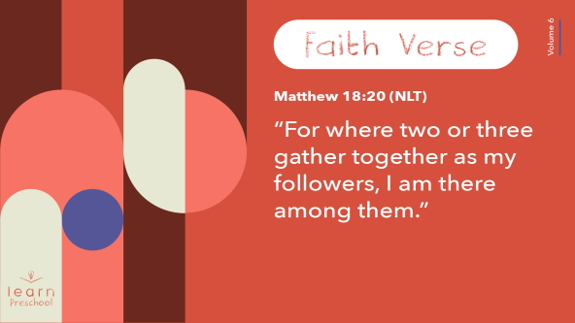

**Closing**

Wow! That was so great. Did you have fun learning about God today? *(Group response)* We’ve worshipped God by singing and praying. We’ve learned a Faith Verse from the Bible. We even learned about an awesome woman named Lydia and how she and her family believed in Jesus and were baptized in water. We have so much we can celebrate.

• *Play the* ***Faith Fact Sound*** *video (bell ringing)*.

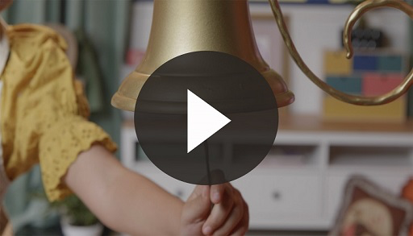

Did you hear that? That special sound means it’s time to practice our Faith Fact one more time: **We celebrate together**.

• *Show the* ***Faith Fact Slide***.



Let’s shout it together. Reach up high and use your big, loud voice. Ready? **We celebrate together.** Now reach down low and use your teeny, tiny voice. Ready? **We celebrate together.** Awesome! I love to celebrate with you.

**Dismissal to Small Groups**

It’s been such a fun time learning together. Now, it’s time to go to our circles where we’ll spend time learning some more about being baptized in water and celebrating together.

• *Dismiss the kids by groups*.

|  |
| --- |
| ***Leader Tip:*** *This can be done by assigning color teams or by age groups. Note that some young preschoolers may not know their age. Using a colored sticker, jersey, or wristband will help separate the kids and help identify their small groups.* |

**Small Group**

**25 Minutes**

*See supplies and prep instructions at beginning of session or in each activity below.*

|  |
| --- |
| ***Leader Tip:*** *Small groups can alternate to each circle, or all groups can do each activity at the same time. If you choose to alternate, you will need at least one leader per circle.* |

**Circle 1**

**Group Connection**

**Pass the Party**

|  |
| --- |
| ***You Will Need***  *• Party hat, one per group*  *• Music*  *• Device to play music on*  ***Getting Ready***  *• Find fun music to play.* |

Today, we learned about celebrating new life in Jesus by being baptized in water. That’s the best reason ever to celebrate. The great thing about this kind of celebration is that everyone can be a part of it. Anyone who chooses to follow Jesus and have new life in Him can celebrate. I love that. I like that kind of party even better than a birthday party because everyone who is baptized in water can be celebrated at the same time. Remember, Lydia’s whole family was baptized in water at the same time. I think they would have celebrated together too.

In fact, we’re going to do a little celebrating of our own right now. I have this party hat and some music. *(Hold up hat.)*

• *Play the music*.

Both of these things make parties extra fun. Let’s sit in a circle and celebrate with the music. We’ll pass this hat around the circle. When you’re waiting for the hat to get to you, I want you to wiggle in your seat. When the music stops, whoever has the hat will say our Faith Fact as loudly as they can. Let’s practice it. **We celebrate together**. Let’s play.

• *Play as long as time allows*.

Great job! You definitely know how to celebrate together.

**Circle 2**

**Activity Page Time**

**Water Baptism**

|  |
| --- |
| ***You Will Need***  *•* ***Small Group Activity Page****, one per kid*  *• Crayons, markers, or colored pencils*  ***Getting Ready***  *• Print copies of the* ***Small Group Activity Page****, one per kid.* |

Who can tell me what happened in the Bible story today? *(Allow responses.)* That’s right! We learned about Lydia and her family being baptized in water. I think they all celebrated together just like our Faith Fact says.

• *Hand out the* ***Small Group Activity Page*** *and crayons or markers to each kid*.

On your page, you’ll see pictures of what happens when someone is baptized in water. Remember what Lizzy told us. Before someone is baptized in water, they ask Jesus to forgive their sins, or those wrong things they have done. That’s what’s happening in the first picture. Did you know that the Bible says even the angels in heaven celebrate when someone asks Jesus to forgive their sins? Isn’t that amazing? *(Group response)*

Then, the rest of the pictures show us what happens when someone is baptized in water. Can you remember what Lizzy said happens? Let’s color the pictures together as you tell me about them.

• *Let kids describe the rest of the pictures*.

• *Optional: Tell about your own experience of being baptized in water as you review the pictures*.

• *During the activity, interrupt and practice the Faith Fact:* **We celebrate together**.

• *Play the* ***Faith Fact Sound*** *video. Review the Faith Fact even if you can’t play the sound*.



**Circle 3**

**Feet-to-Floor Game Time**

**Balloon Catch**

|  |
| --- |
| ***You Will Need***  *• Small balloons, one per kid*  *• Plastic cups, one per kid*  *•* ***Countdown60 Video****–60 seconds*  ***Getting Ready***  *• Blow up the balloons to a size that will rest on top of the cups.* |

If you’re ready to play a game, wave your hands in the air. *(Group response)* Today, we learned that we celebrate together. No celebration is complete without balloons. In our game, we’ll see who can catch the most balloons. But, you can’t catch them in your hands. You have to catch them in a cup.

• *Demonstrate how to catch a balloon*.

When you’ve caught a balloon, shout out our Faith Fact: **We celebrate together.** Then, toss your balloon back up in the air. I’ll keep track of how many balloons we can catch all together in one minute. Ready to play?

• *Give each kid a cup and a balloon*.

• *Start the* ***Countdown60 Video*** *and have kids toss the balloons up in the air*.

• *Count how many balloons the kids catch before time is up*.



Wow! That was a really fun way to celebrate together. Great job!

• *Play again if you have time*.

**Circle 4**

**Hands-On Learning**

**Spread the Celebration**

|  |
| --- |
| ***You Will Need***  *• Small foam or plastic cup, one per group*  *• Large plate, one per group*  *• Baking soda*  *• Vinegar*  *• Tablecloth*  ***Getting Ready***  *• Cover the table with a tablecloth.* |

Being baptized in water is about celebrating what Jesus has done for everyone who follows Him. Who loves Jesus? *(Group response)* I love Jesus, too. When we decide to follow Jesus and ask Him to forgive our sins, He does. I’ve got an experiment that will tell us more about that. Let’s pretend this cup represents you and me.

• *Hold up the cup and then set it on the plate*.

When we ask Jesus to forgive our sins, He does.

• *Add baking soda to the cup*.

It’s awesome because then Jesus is right here with us. If we don’t tell others about Jesus, can other people see Him? *(Group response)*

We don’t want to keep Jesus hidden. The Bible says we should tell others about Jesus. Being baptized in water is one way to do that. We show and tell others that we love Jesus.

• *Add vinegar to the cup*.

We show others that we love Jesus. Our love for Jesus on the inside comes out for everyone to see. In fact, it starts to bubble over, and everyone can tell that we’ve decided to follow Jesus. Others are excited that our faith is growing. What’s on the inside is now clear for everyone to see on the outside. It’s so awesome that they want to celebrate with us. That’s what our Faith Fact says. Say it with me. **We celebrate together**.

**Dismissal**

• *Play the* ***Faith Fact Sound*** *video (bell ringing)*.



• *Show the* ***Faith Fact Slide***.



You kids have done such a great job as we learned about being baptized in water. Before we leave, let’s say our Faith Fact one more time. Ready? **We celebrate together**.

• *Send home the* ***Small Group Activity Page*** *with each kid*.

• *Remind parents that there are* ***Family Devotions*** *available on the app to do with their kid*.

• *Tell everyone the date and time for the next session*.